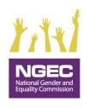
REPORTING TOOL ON GENDER MAINSTREAMING IN THE GOVERNMENT OF KENYA 2021/2022

Public Sector Quarterly Gender Mainstreaming Reporting Tool FY 2021/22
Reporting Period: …………………………………………………………………………………………………………………………………………
Full Name of the Ministry, Department, Agency or County: ………………………………………………………………………
- Type of Institution(Tick where applicable)
- Ministry/State Department  - State Corporation  - Public University |  |  |  | - Tertiary Institution  - Semi-Autonomous Govt Agency  - County Government  - Others(specify)__________
B. Indicators
- Were gender mainstreaming activities included in the annual work plan? |  |  |  |  |  |  |  |  |  | [Yes] [No]
2. Has the institution established or reconstituted any of the following gender mainstreaming structures:  - A gender focal person  - A gender mainstreaming committee  - A gender directorate, department, unit, division or section  - None of the above |  |  |  |  |  |  |  |  |  | (Tick appropriately)
3. Were the members of the structure in (2) above trained on gender mainstreaming issues? |  |  |  |  |  |  |  |  |  | [Yes] [No]
4. a) What is the total amount of the MDA's 2021/22 annual budget.  b) What amount was allocated for Gender Mainstreaming in the reporting period? |  |  |  |  |  |  |  |  |  | Total budget:  Ksh………………….  Budget for Gender mainstreaming: Ksh.…………………
5. Did the MDA develop/review a Gender Mainstreaming Policy in line with the National Policy on Gender and Development, 2019? |  |  |  |  |  |  |  |  |  | [Yes] [No]
6. Did the MDA implement the Gender Mainstreaming Policy in (5) above? |  |  |  |  |  |  |  |  |  | [Yes] [No]  If yes, what actions (Attach evidence to the report)
7. Did the MDA develop/review a workplace Policy on Gender Based Violence (GBV) in line with the National Policy on Prevention and Response to Gender Based Violence 2014? |  |  |  |  |  |  |  |  |  | [Yes] [No]
8. Did the MDA implement the workplace Policy on Gender Based Violence in (7) above? |  |  |  |  |  |  |  |  |  | [Yes] [No]  If yes, what actions (Attach evidence to the report)
 | Indicators |  |  |  | Sex |  | Persons With Disabilities |  | Minorities &  Marginalized  Communities |  |  | Age Category
 |  |  |  |  | F | M | F | M | F |  | M | Below 35 |  | 35 & above | Total
 | 9. Total number of staff in MDA
 | 10. Number of employees in job group N and above or its equivalent
 | 11. Number of board members or its equivalent
 | 12. Number of gender mainstreaming committee members trained
 | 13. Number of board members/senior management trained on gender mainstreaming in the reporting period.
 | 14. Number of employees Sensitized on Gender issues in the reporting period
 | 15. Number of recruited officers in the reporting period including interns and attachees
 | 16. Number of officers promoted in the reporting period
C. Please highlight some of the emerging issues or challenges faced in the process of mainstreaming and integrating gender equality in your institution
……………………………………………………………………………………………………………… ………………………………………………………………………………
………………………………………………………………………………………………………………………………………………………………………………………………

- Submit to the State Department for Gender on Email: pcontracting5@gmail.com and a copy to the National Gender and Equality Commission: Email: pcontracting@ngeckenya.org

Note: This reporting tool should be signed and stamped by the Accounting Officer.

- Name of Accounting officer:………………………………………………………………. Signature:……………………………….. Date…………………….

 | Name of Reporting Officer | Designation | Telephone Number |  |  |  |  | Email Address |  |  |  |  | Date

Page 2 of 2

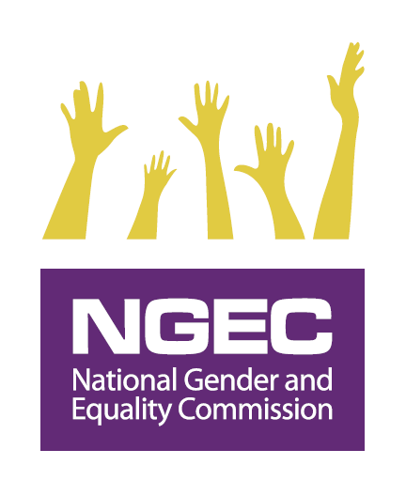
MEASURING PERFORMANCE ON THE GENDER MAINSTREAMING INDICATOR: 2021/2022 PC

Indicator in PC Guidelines | Indicator No. as per Reporting Tool | Variables in the Reporting Template | Weight/Score
- Establish or reconstitute a functional gender committee and train members on gender equality by 31st October 2021 | No 2: Existence of a gender mainstreaming structure (5% Score). Such a structure may consist of either one or more of the following:  - A gender focal person  - Gender mainstreaming committee  - Gender directorate/department/division/unit/section | - Structure | (20% Score)
 | No. 3: Members of the structure in (2 above) trained (10%)
 | No 4 b): Amount set aside for Gender Mainstreaming in the reporting period? (5% Score). | - Resources
- Domesticate / customize the National Policy on Gender and Development 2019 to organizational needs by 31st March 2022 | No 5 and 6: Development/Review of the Gender Mainstreaming Policy (5% Score) and implementation of a Gender Mainstreaming Policy (10% Score) ( total 15% Score) | - Policies  - Activities derived from the policies | (30% Score)
 | No 7 and 8: Development/Review of a Workplace Policy on Gender Based Violence (5% Score) and implementation of GBV Policy (10% Score) (total 15% Score)
- Undertake capacity building on gender for staff | No 12, and 13: Training of the board members/senior management and committee members on gender mainstreaming in the reporting period(20 % Score)  No.14 Sensitization of the staff on gender mainstreaming in the reporting period (10 % Score)  No 9, 10, 11, 15 and 16: Disaggregation of data on all employees as guided in the reporting tool including on recruitment and promotions (5% Score).  Check for attainment of two thirds gender principle (2%) and for attainment of at least 5% for PWDs (3%) (Total 5% Score) | - Number of participants by:  - Sex  - Ability  - Ethnicity  - Age | (40% Score)
- Submit quarterly reports using the prescribed format to the State Department for Gender with a copy to National Gender and Equality Commission | No 1: Institutional work plan with gender mainstreaming actions and/or activities included (2 % Score) | - Annual GM work plan  - Submission timelines  - Correct reporting format | (10% Score)
 | Section E: Submission of the quarterly report using the reporting template as provided and observing deadlines (8 % Score)
Total Score |  |  | 100%

For more information about the policy visit http://psyg.go.ke/wp-content/uploads/2019/12/NATIONAL-POLICY-ON-GENDER-AND-DEVELOPMENT.pdf
For more information about this policy visit http://psyg.go.ke/docs/National%20Policy%20on%20prevention%20and%20Response%20to%20Gender%20Based%20Violence.pdf

